**Submitting a Journal to PubMed Central and Linking it to an NIH Grant**

Berkeley Population Center, UC Berkeley

(revised June 2025)

*If you find that the process is different than what is described below, please email Max Méndez Beck* [*maxmendezbeck@berkeley.edu*](mailto:maxmendezbeck@berkeley.edu) *at the Berkeley Population Center.*

**Section I. Definitions and Basic Requirements**

A peer-reviewed article that is the result of at least partial NIH funding must be submitted to PubMed Central through NIH’s public access system in order to get a PMCID assigned to it. THEN it needs to be associated with the grant(s) that funded the work, including the grants that supported your students (e.g., T32). Ideally of course this should also be in your acknowledgements.

The NIH Public Access Policy requires the submission of Author Accepted Manuscripts for publication on or after April 7, 2008. An Author Accepted Manuscript is defined as “The author’s final version that has been accepted for journal publication and includes all revisions resulting from the peer review process, including all associated tables, graphics, and supplemental material.” This means that you do not submit material that is not peer reviewed (editorials, commentaries, etc.) or lacks appropriate funding.

The [2024 NIH Public Access Policy](https://grants.nih.gov/grants/guide/notice-files/NOT-OD-25-047.html) requires “Author Accepted Manuscripts accepted for publication in a journal, on or after July 1, 2025, to be submitted to PubMed Central upon acceptance for publication, for public availability without embargo upon the Official Date of Publication,” which is defined as, “the date on which the Final Published Article is first made available in final, edited form, whether in print or electronic (i.e., online) format.”

Note: The PMCID number MUST be cited whenever you submit almost anything to NIH, including but not limited to biosketches and articles cited in progress reports. The University is the official grant holder, and they too are obligated to check, and NIH has provided them with a software tool to try to do just that.

***Grant awardees who are not in compliance will not receive funds.***

**PMCID ≠ PMID**

The PMCID number is NOT the same as a PMID. The PMID is the number assigned by PubMed, but not by NIH public access. The PMID represents a citation and an abstract. The PMCID is for the entire paper and is the number that gets linked to the grant. The PMCID number is the only way to prove compliance with NIH’s policy.

**From NIH:**

*“The Difference Between a PMCID and a PMID*

The PubMed Central reference number (PMCID) is different from the PubMed reference number (PMID). PubMed Central is an index of full-text papers, while PubMed is an index of abstracts. The PMCID links to full-text papers in PubMed Central, while the PMID links to abstracts in PubMed. PMIDs have nothing to do with the NIH Public Access Policy.”

Assuming your article was indeed at least partially funded by NIH (including if your student researchers were funded off the grant while they supported this effort), then the process for compliance is as follows.

Here is a FAQ for PubMed Central: <https://publicaccess.nih.gov/faq.htm>

**Section II. Determining the status of your article in PubMed Central.**

**A.** Some journals automatically submit the article to PubMed Central.Others don’t. See the chart in the box provided by NIH for the kinds of processes journals are now following.

**Method A**. It may be that your *journal* automatically submits your article to NIH: https://publicaccess.nih.gov/submit_process_journals.htm#journals, in which case you don’t have to do anything, but note that some journals began this automatic process only recently, in which case you may have to proceed to Method C or D. You will still have to add the grant info.

**Method B**. It may be that the *publisher,* e.g., has an arrangement with NIH, but you have to contact the publisher directly to make sure this happens, and sometimes there’s a fee.

Publishers: <http://publicaccess.nih.gov/select_deposit_publishers.htm>.

**Method C**. Neither the journal nor the publisher does anything automatically; it’s up to the author, any author.

**Method D**. The publisher deposits the article itself into PubMed Central, but the author (any author) has to finish up the details and complete the process in order to have the PMCID assigned. Essentially you follow steps for Method C except the article should already be in the system; you just add the grant info. Elsevier says they do this when the author indicates NIH support. <https://publicaccess.nih.gov/MethodDPublishers>.

Here’s a summary of the four processes: <http://publicaccess.nih.gov/submit_process.htm>

**B.** Use the PubMed search tool to see if there’s a PMCID number for your article: <http://www.ncbi.nlm.nih.gov/pubmed>.

*Hint: Search by article title or by author lastname firstname – no comma between names. Use the less common co-author surname for ease.*

**If there IS a PMCID number** – you have to click on the article to see, although it should say PMC Article -- that’s good. Then click on the link with Grant Support, and scroll down to see if your grant is listed. If so, you are in compliance. If YOUR grant number isn’t there (your co-author may have listed his/hers already) then you will have to associate the paper with the grant.  **=> Go to Step 6.**

**If there is no PMCID number**, then you need to find out about submitting your paper and get one. You must also investigate the copyright requirements of your journal’s publisher.

**Section III: Submitting an article to PubMed Central.**

Here are the steps for the Author (or delegate) to submit an article:

1. **Obtain a copy of the accepted pre-publication peer-reviewed manuscript.** This is the Author Accepted Version that has been accepted for journal publication and which includes all revisions resulting from the peer review process, including all associated tables, graphics, and supplemental material. The manuscript does not include publisher stylistic edits/copyediting.

,.

1. **Go to NIHMS website and log into MyNCBI:** 
   1. Do not use Firefox to submit a manuscript (but it can be used to associate a manuscript to a grant), but Chrome should work. I do not know how well other browsers work. You can click on the NIH login <https://www.nihms.nih.gov/login/?next=/submission/> and use your eRA commons user id and password. Otherwiseyou can even use your Google account, or in some cases, your university has an arrangement (e.g., UCSF), which is nice if you don’t have an ERA Commons number (as might be the case for, say, a delegate or non-PI co-author).
   2. Once you are logged in, go to this link <https://www.nihms.nih.gov/db/sub.cgi>. lick on the **Submit New Manuscript** box, upper right. If the article already has a PMID in PubMed you can use that. You can use the DOI, or alternatively, it could be listed in your MyNCBI already. Most likely, however, you will be entering manually.
2. If the article has not yet been submitted to PubMed Central, then the submission and the association of the grant occur simultaneously. Ideally this is what could be done but of course, there are often more than one applicable grant.

If the paper is already in PubMed Central as evidenced by the PMCID number (or the temporary NHIMS number), then go to Section II. If there is no paper and thus no grant number, continue to Step 4, below. [Again, if it has a PMID number, it’s just the abstract, not the entire paper.]

1. You will need the following things to submit the article
   1. Exact manuscript title
   2. Exact journal title
   3. Grant numbers (The Popcenter’s is P2CHD073964 (PI: Joshua Goldstein); CEDA’s is P30 AG012839 (PI: William Dow); the demography and economics of aging training grant is T32 AG000246 (PI: Joshua Goldstein); the NICHD interdisciplinary demography training grant is T32 HD007275 (PI: Dennis Feehan). You can look in the [NIH RePORTER](https://reporter.nih.gov/) for the number on other grants, though it should be listed in the About page of a project website.
   4. Manuscript file in any format, with all required files (text, drawings, etc.).
   5. If the manuscript is already in PubMed Central, then proceed to step 6.
2. Follow the step by step instructions to Upload the Journal Article.
   1. Enter journal name (it’ll help you finish the text) and title manually if the journal is already in the PubMed system.
   2. Click on the Next button to go to the Funding section. There you should see the grant listed, check the box for the appropriate grant(s). Or, search by grant number, and/or first name, last name of the PI (e.g. Joshua Goldstein for the Popcenter P2C). Click on Next.
   3. Upload the file, and if relevant, separate figures, etc. Click on Next.
   4. If you are uploading an article that is not written by you (e.g. you are a grad student doing this for your professor), then you must designate a reviewer, that is, one of the authors. Note the endorsement guidelines.
   5. Release embargo: You will need to refer to the journal’s or publisher’s policy regarding this. Indicate your choice and then click on Next. If you are designating another Reviewer they will be required to complete the Release embargo. *Note there is no embargo period for manuscripts accepted for publication on or after July 1, 2025*.
   6. Indicate agreement with requirements, or send to the Reviewer.
   7. You will then receive an interim NIHMSID number.
   8. The Reviewer will have to review and approve.

Step 6: Associating an existing PMCID paper with your grant.

1. Start at MyNCBI: <http://nihms.nih.gov>. The only way to link it is if the paper is already in the system and also, in your My Bibliography at MyNCBI. If you can’t log in, try using the email option. Best to use Chrome, not sure about other browsers but often if something just doesn’t work, it’s because of the browser.
2. Enter the Journal Name and article title. Or, if it’s in the system, you can use the PMID number.
3. At the upper right, there is a small blue link, **‘Grants Reporting’.**
4. You will see the article in question, with a column on the far left called “grants”. Click on that, and your grant should be listed below. Check the box to associate the paper with the grant.
5. Click on update, and you’re done.

I strongly recommend adding the PMCID number to your CV and it MUST be cited whenever you submit almost anything to NIH, including but not limited to biosketches and articles cited in progress reports. Citation examples from NIH are here <https://publicaccess.nih.gov/include-pmcid-citations.htm#Examples>.

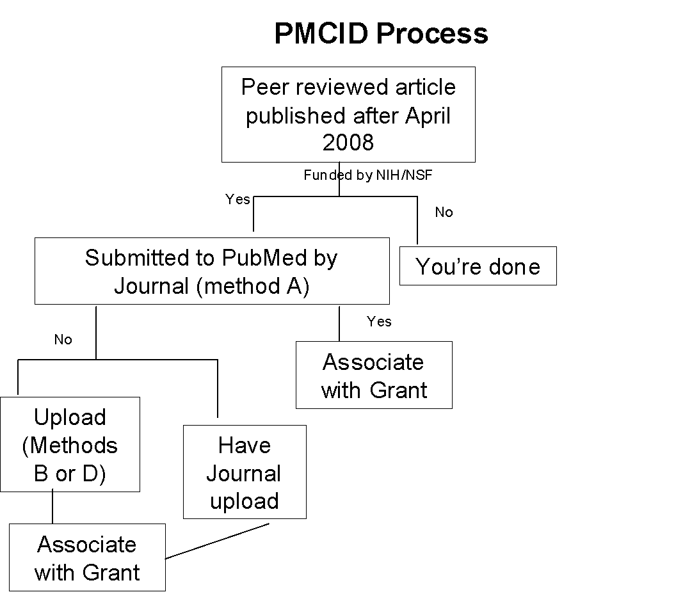

**Selected Publisher Copyright Agreements regarding NIH PubMed**

***\*Effective July 1, 2025, there will no longer be an embargo period***

Once submitted, the NIHMS review process takes approximately 2 to 3 weeks to complete. Reviewer/author will receive emails requesting final approval before PMCID is assigned. See explanation of process below:

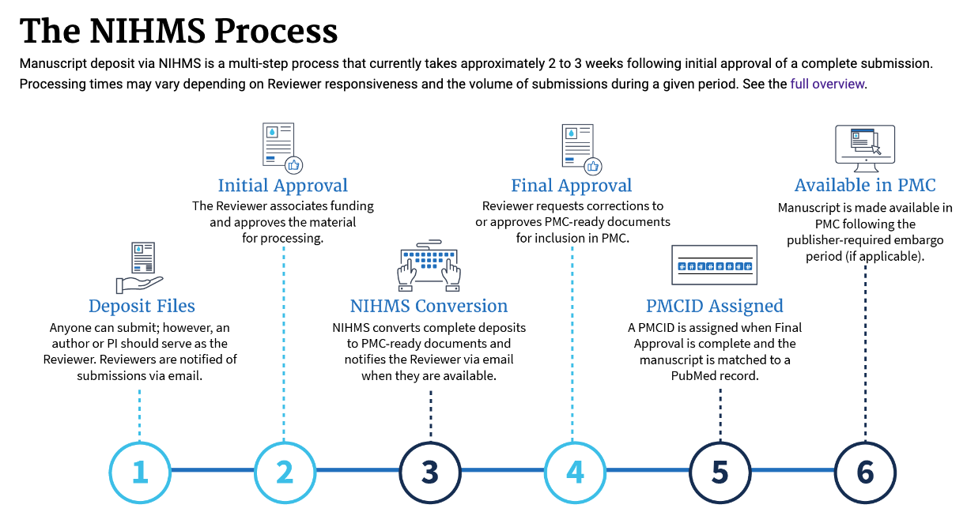

For any assistance with this process, please reach out to Max Méndez Beck at the Berkeley Population Center.